Ansible

**Aim**: - Create Playbook handlers on ansible-controller and Create ansible with windows-host using on azure portal

**Create Playbook handlers on ansible-controller and Create ansible with windows-host using on azure portal**

**Create a Playbook using yaml file:**

To create handler by using following command:

#vi handler.yaml

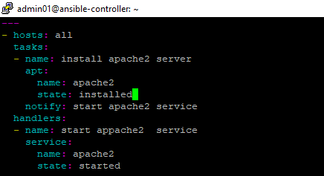

#ansible-playbook handler.yaml -b

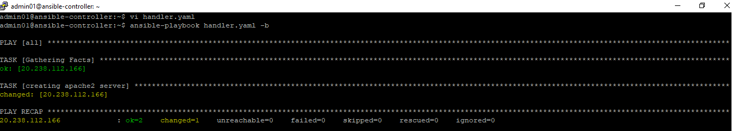

**To create ansible with Windows Host:**

To create a windows host on azure portal:

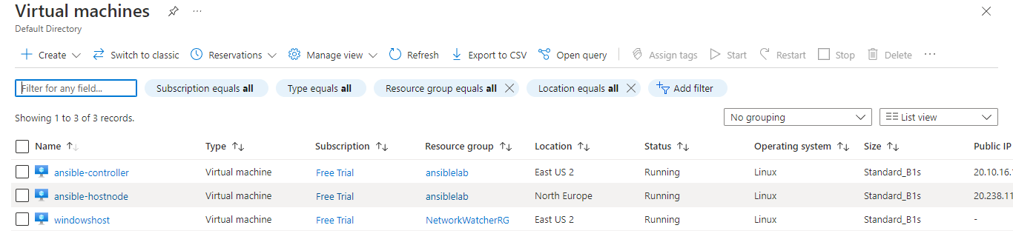

TO Setup WinRM in Windows Machine to Prepare for Ansible

>iex(iwr <https://raw.githubusercontent.com/ansible/ansible/devel/examples/scripts/ConfigureRemotingForAnsible.ps1).Content>

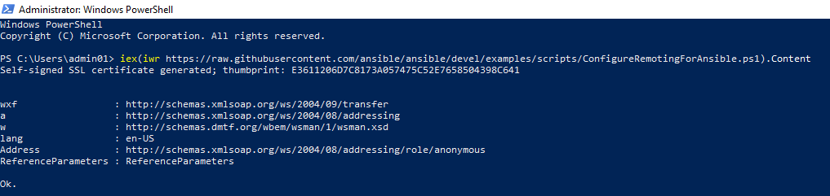

To check if winrm listens on the port 5986

>netstat -anp|findstr 5986

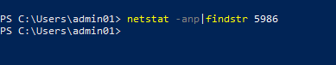

To add and allow inbound port5986 in winhost vm.

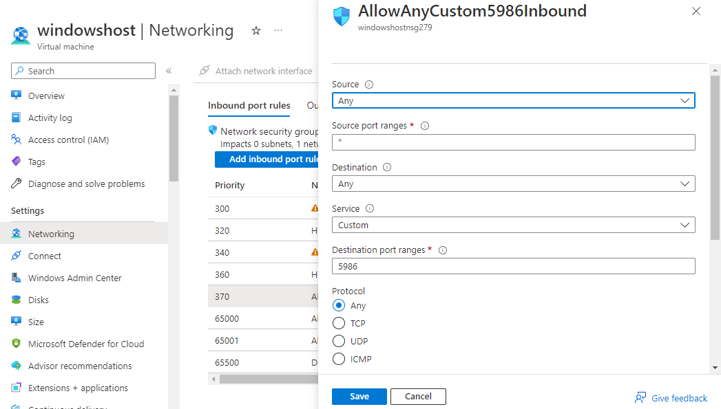

To install python3-pip packages on ansible-controller vm:

#sudo apt install python3-pip

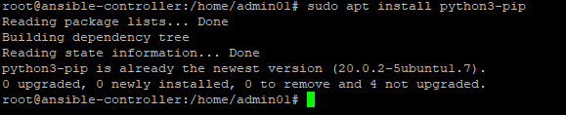

To make sure that the network connectivity is there to the remote machine

#nc -w 3 -v 20.226.48.83 5986

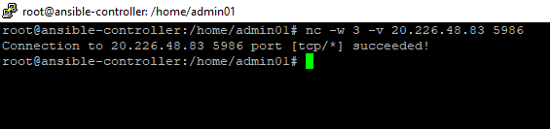

To create a hosts inventory for windows host:

#vi winhost1

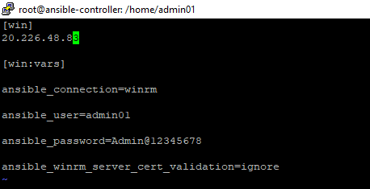

Ansible win_ping , to check the connectivity from Control machine to Windows.

#ansible win -m win_ping -i winhost1

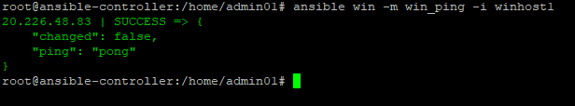

To check the windows hostname by using the following the command:

# ansible win -m win_shell -a "hostname" -i winhost1



To check the windows date by using the following command:

#ansible win -m win_shell -a "Get-Date" -i winhost1

